Smokin’ Bones BBQ
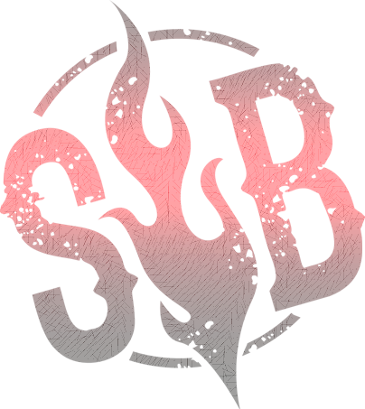
Sandwich Menu
Beef Brisket Sandwich w/ Side $15
Pulled Pork Sandwich w/ Side $13

Specialty Items
Spare “Ribs Tips” w/ Side $14
Hot Link “Hoagie” w/ Side $12
Brisket “Burger” w/ Side $12
New Specialty Items
“Big Moo” Sandwich w/ Side $17
(Brisket Burger & Sliced Brisket Combo Sandwich)

“Big Oink” Sandwich w/ Side $16
(Pulled Pork & Hot Link Combo Sandwich w/ Coleslaw)

“Big Twist” Sandwich w/ Side $16
(Brisket Burger & Hot Link Combo Sandwich)

“Grilled Chicken” Sandwich w/ Side $13
(“Jerk” or “Blackened” Chicken Sandwich w/ grilled Pineapple)
Sides

Potato Salad Coleslaw Baked Beans

Mac n Cheese Chips

